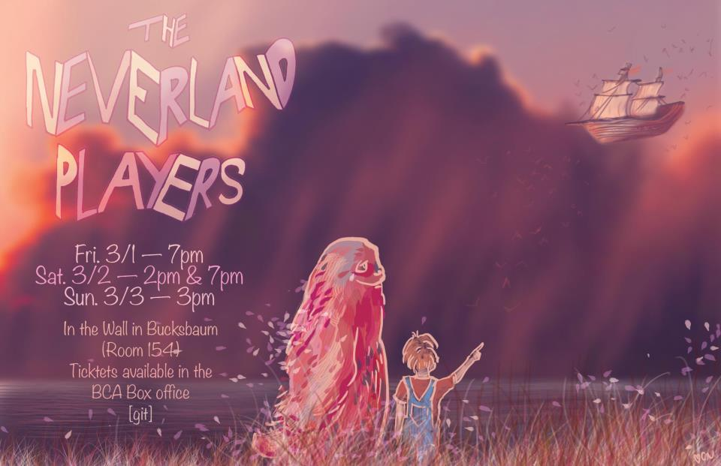

Saturday, March 9

2:00 pm

Original stories written by local kids

Performed on stage

for all ages.